CHAPTER 5: Separating mixtures
Worksheet 5.5

Crystallisation and distillation
Science Quest 7: pages 190–193
Student: Class:
You will need:  Bunsen burner, matches and heatproof mat  tripod and gauze mat  evaporating dish  salt water  safety glasses and laboratory coat  distillation kit (such as Quickfit apparatus).  Part A: Crystallisation  ● Pour a small amount of salt water into the evaporating dish.  ● Put the evaporating dish on the gauze mat as shown.  ● Gently boil the salt water until most of the water has evaporated.  ● Once the dish has cooled, observe its contents.  1. What residue has formed in the dish?  2. What has happened to the water? | 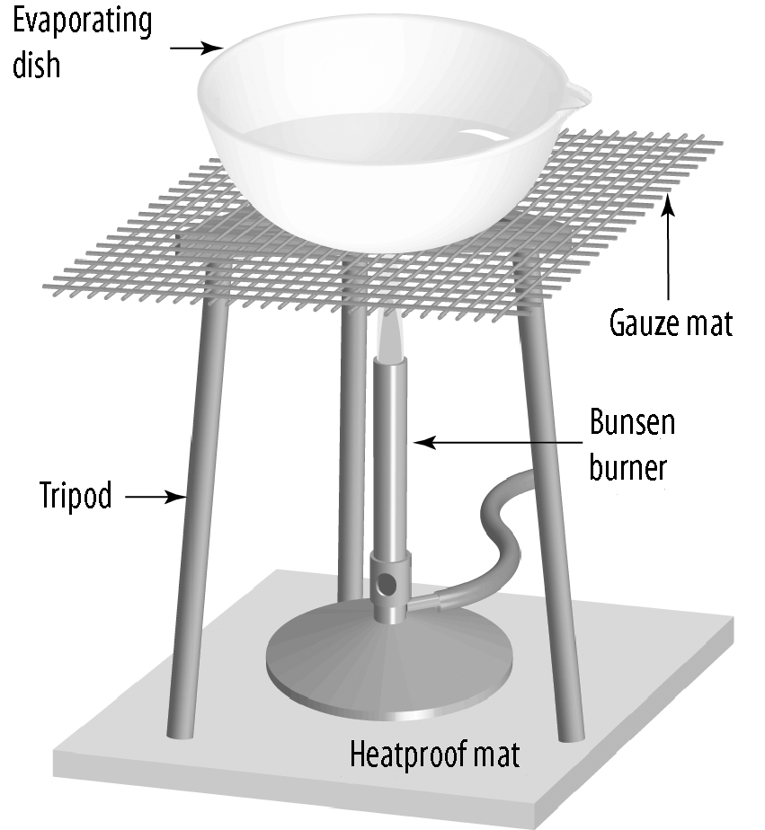  3. This method of separation is called crystallisation. What could it be used for?
Part B: Distillation (teacher demonstration)  ● Set up the distillation equipment as shown.  ● Pour a small amount of salt water into the boiling flask.  ● Gently boil the mixture until most of the water has evaporated.  4. Describe what you see during the distillation.  5. When would distillation be used instead of crystallisation? | 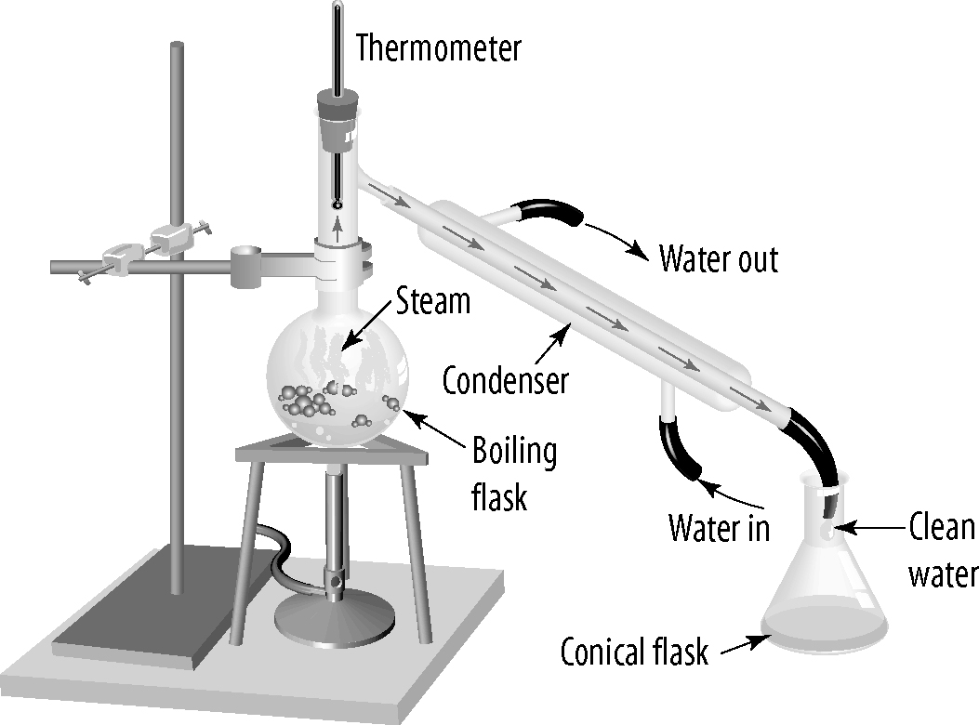
6. What is the purpose of the condenser?

